Task 1: Print First 10 natural numbers using while loop
Expected output:
0
1
2
3
4
5
6
7
8
9
10

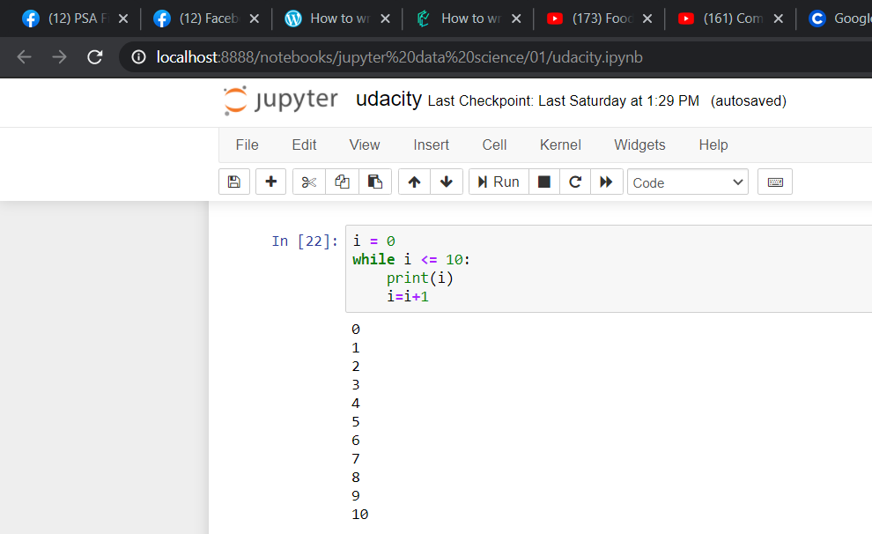

Task 2: Accept number from user and calculate the sum of all number from 1 to a given number

For example, if user entered 10 the output should be 55.

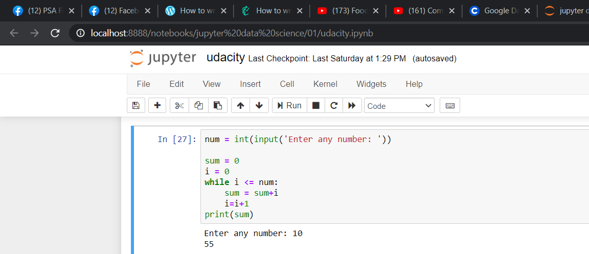

Task 3: Print multiplication table of a given number
For example, num = 2 so the output should be
2
4
6
8
10
12
14
16
18
20

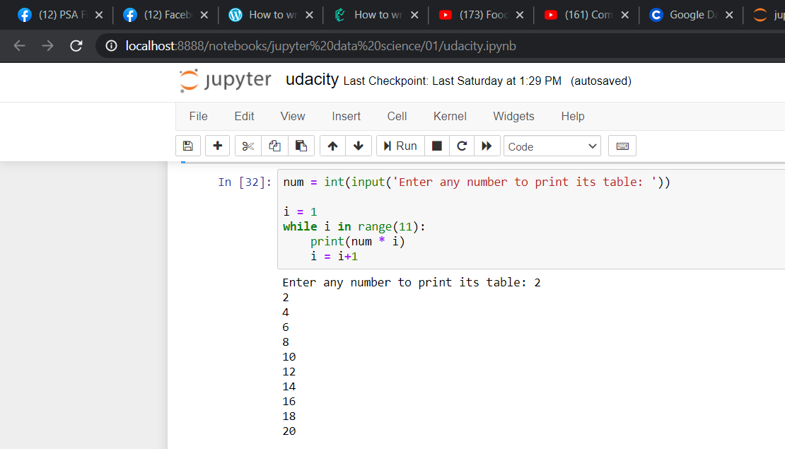

Task 4: Given a list, iterate it, and display numbers divisible by five, and if you find a number greater than 150, stop the loop iteration.

list1 = [12, 15, 32, 42, 55, 75, 122, 132, 150, 180, 200]
Expected output:
15
55
75
150

